(**5 points) –** Test the Home view - Minimum changes - Title, application name and footer changed, body’s background color and the h1, h2 and h3 colors are changed in the bootstrap.css file.

* + 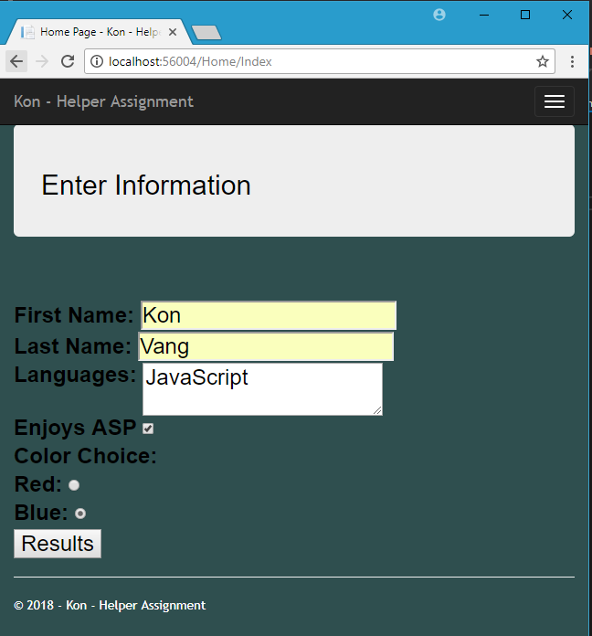Paste your **Index** view with your information entered:
* **(15 points) -** Test the Home and Students view. Does the data display correctly? Is the data displayed neatly?
  + 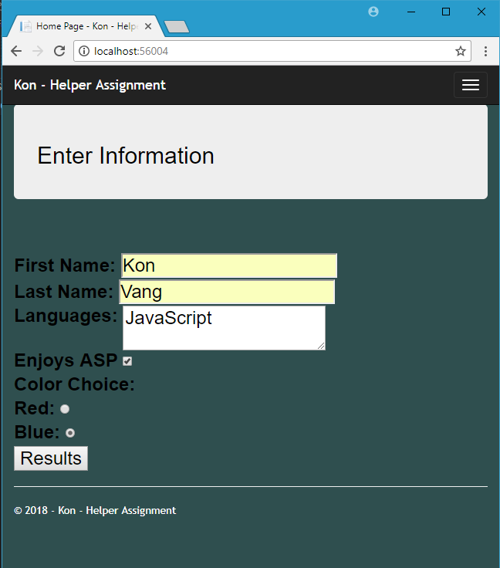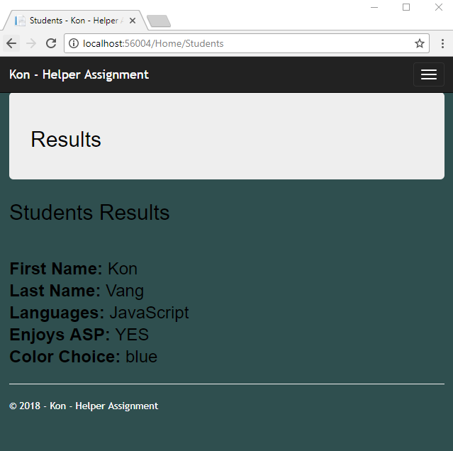Paste your **Students** view showing the correct results, as shown in the sample results above:
* **(10 points) -**
  + Add 1 more input textbox and 2 more radio buttons of your choice to your Index view. Add corresponding descriptive labels. Just adding additional colors does not count. This means to add another label and corresponding input textbox for the user to enter some new data and another label/topic and 2 other corresponding radio button choices.
    - All information entered on the Index view should display on the Student view.
    - There should not be any input textboxes on the Students view.
    - Clicking the Menu/Home will return to an empty home/index page.
    - 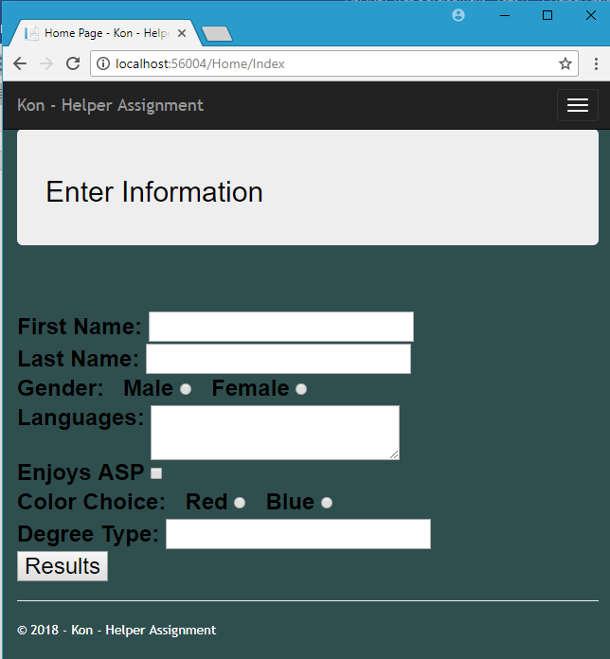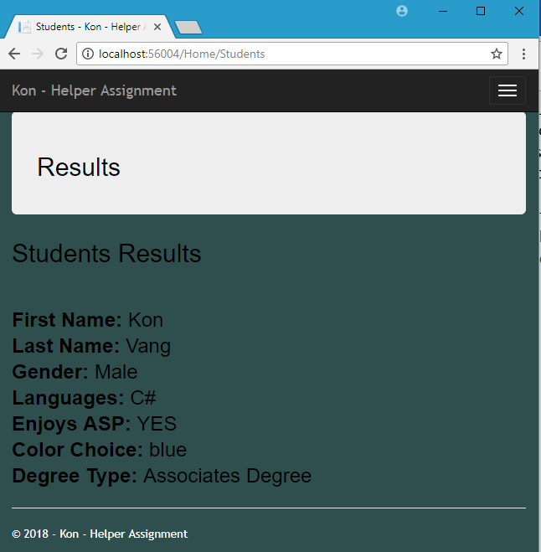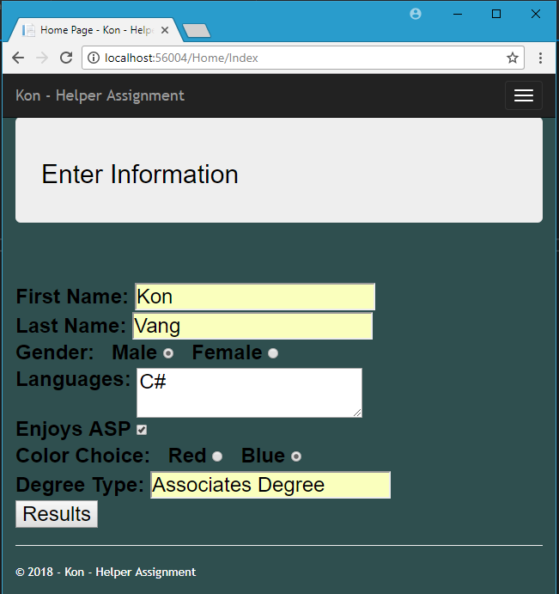Paste your results of testing your new changes (both the Index and Students views)
* **(5 points) -** Save All / Zip your project / Submit your word doc. and zip file
  + Submit a word document (only pages 15-16 about – don’t need the to submit the entire document!), including the required screen prints shown above - with your own data entered.
  + Your results view should also show **Home / Student** in the url.